Experiment 1: Airline Ticket Booking System

Aim
To design and develop an Airline Ticket Booking System using Zoho Creator that enables users to book flight tickets, calculate the total fare, and generate booking confirmation automatically.

Procedure

Step 1:

Log in to Zoho Creator.

Step 2:
Click Create New Application.

Step 3:
Enter the application name: Airline Ticket Booking System

Step 4:
Create a form named: Airline Ticket

Step 5:
Add the following fields:
FIELD NAME | FIELD TYPE
Phone | Phone
Name | Name
Age | Number
From | Single Line
To | Single Line
Email Id | Email
Number Of Passenger | Number
Date | Date
Cost Of Ticket | Currency
Passenger Id | Auto Number
Flight No | Single Line
Total | Currency

Step 6:
Save the form.

Step 7:
Go to: Workflow → On User Input
Choose The Field: Number Of Passenger

Step 8:
Write the Deluge script:

if(input.Cost_Of_Ticket != null && input.Number_Of_Passenger1 != null)

{

input.Total = input.Cost_Of_Ticket * input.Number_Of_Passenger1;

}

alert "🎉 Ticket Successfully Booked!\n\nPassenger Name : " + input.Name + "\nFlight No : " + input.flight_no + "\nTotal Amount : ₹" + input.Total;

Step 9:
Save the workflow.

Step 10:
Open the application and enter the passenger details.

Step 11:
Enter the Cost of Ticket and Number of Passenger.

Step 12:
The application automatically calculates and displays the Total amount.

Step 13:
Click Submit to save the booking.

Step 14:
View the saved booking details in the report.
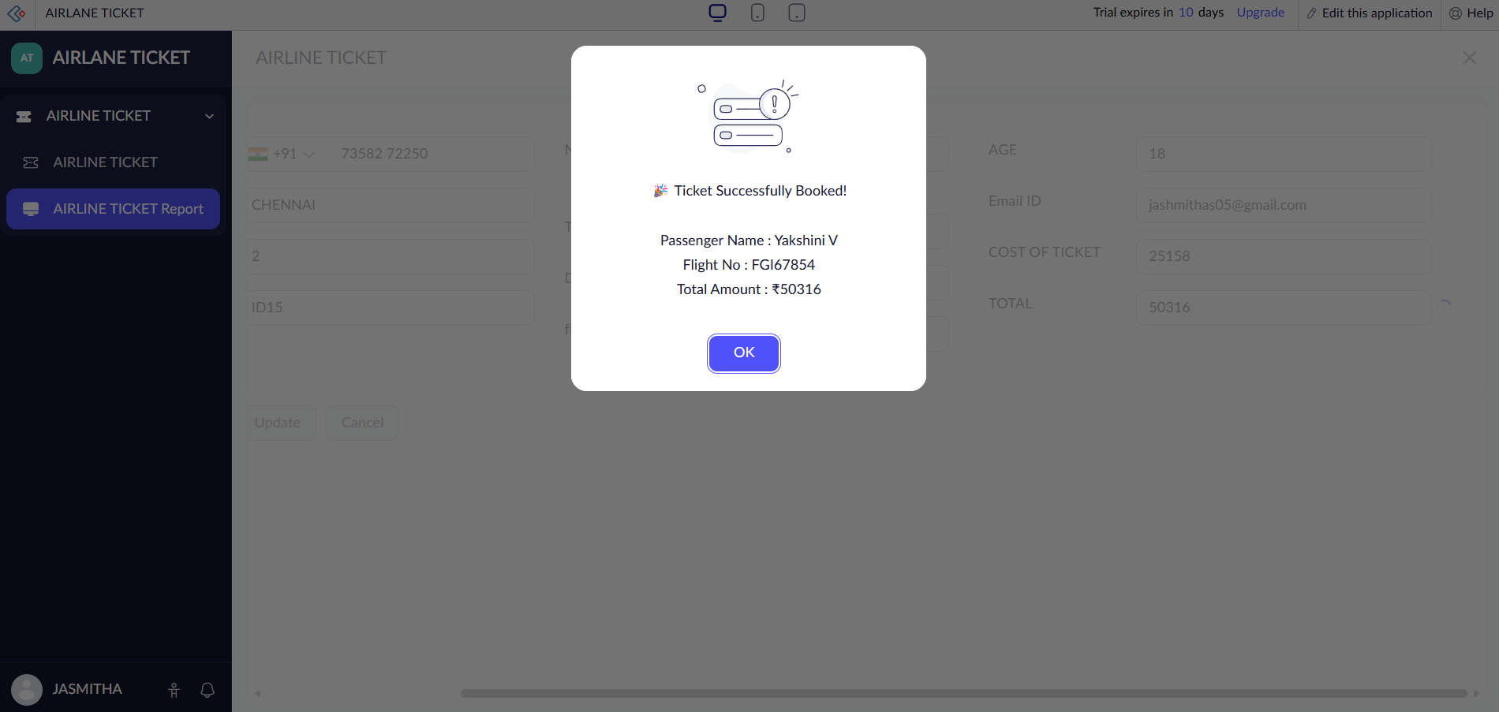
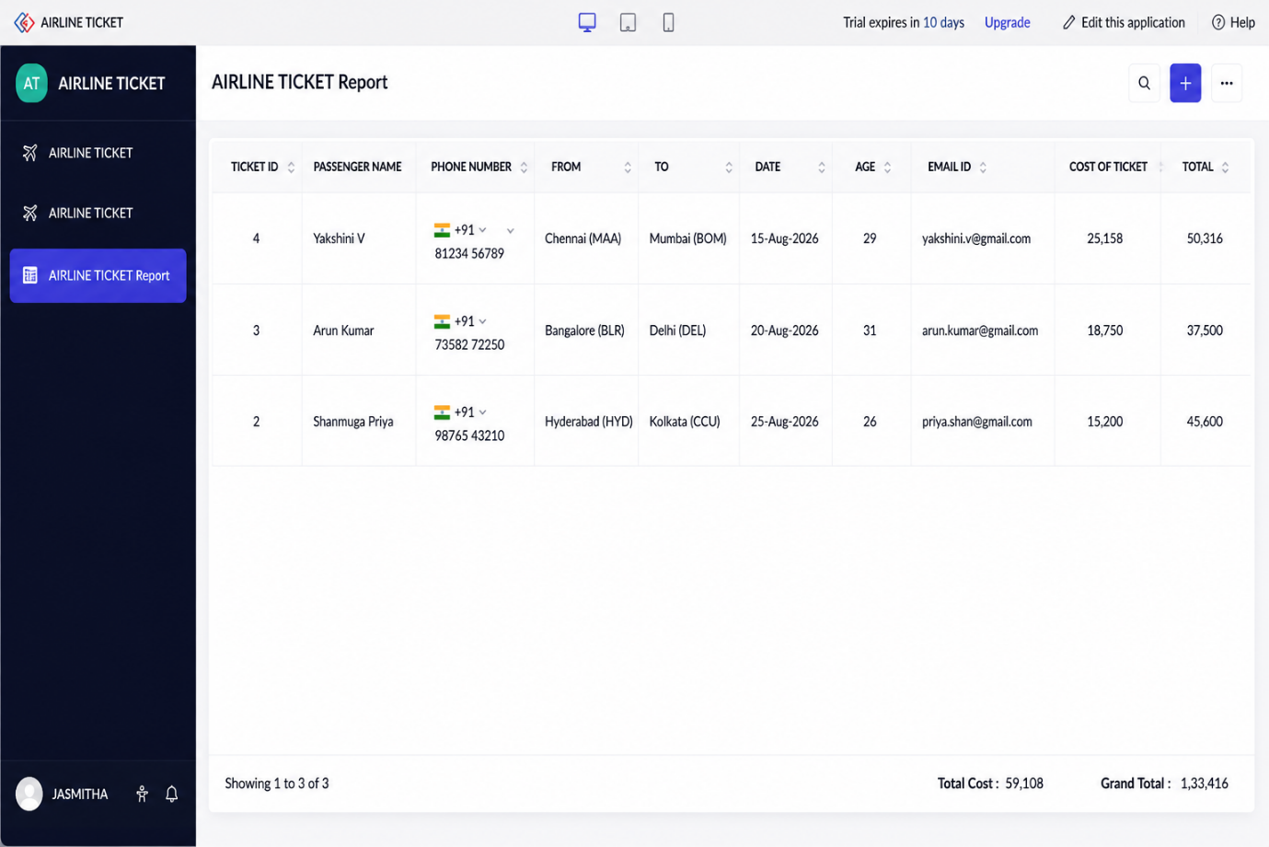
Implementation
The Airline Ticket Booking System was implemented using Zoho Creator forms, workflows, and reports. The system automatically calculates the total fare based on the ticket price and number of passengers. After the booking is completed, the booking status is updated and a confirmation message is displayed. Reports are generated to manage passenger booking details efficiently.

